Aspen Pest Complex (Venturia, Leaf Miner, Tortrix)

Large Aspen Tortix ( Choristoneura conflictana) IDX
Aspen Serpentine Leaf Miner (Phyllocnistis populiella) ID6
Aspen Shoot Blight (Venturia populina) DLV

Description
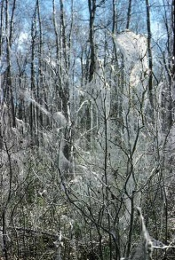
Large Aspen Tortrix: Trembling aspen and balsam poplar are susceptible. Appear as dark, smooth caterpillars feeding within rolled or webbed leaves, with egg masses on the foliage. Affected foliage has a clumped, irregular appearance. The infestations usually last 2 to 3 years, recurring about every 10 years. Severe defoliation can result in reduced radial growth, but only rarely results in tree mortality. Outbreaks of the large aspen tortrix tend to precede those of the forest tent caterpillar.

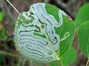
Aspen Serpentine Leaf Miner affects trembling aspen and occasionally black cottonwood. Newly hatched larvae feed on tissue between the epidermal leaf layers. The foliage of aspen which has been heavily attacked appears bleached-white before changing to a yellow-brown colour. Heavy attacks can reduce tree growth, cause branch dieback and even cause mortality. Foliage discoloration and premature leaf fall may reduce the aesthetic value of trees on recreation sites.
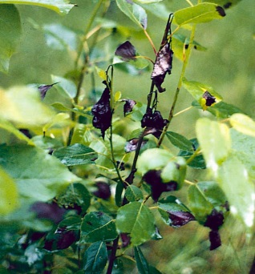
Aspen Shoot Blight is widely distributed throughout the range of its hosts in B.C. Venturia macularis is especially severe in northern B.C. Venturia macularis attacks primarily trembling aspen. Venturia populina attacks balsam poplar, hybrid poplars, and black cottonwood. The fungi overwinter on dead shoots, leaves, and blighted twigs. Spores are dispersed in the spring via wind and rain to infect newly formed shoots and leaves. The fungus first appears as black leaf spots. The spots will continue to spread down the leaves into succulent branchlets. The infected new shoots and leaves will turn black and wilt, resembling a shepherd's crook. A velvety mat of olive-green conidia (spores) are produced on the blackened, dead tissue. Wet springs and summers are optimum conditions for infection. Crowns are stunted and deformed when Venturia infections occur over successive years.

Extent
See map at the end of this section

Data
Tactics

